A CRM application for schools and colleges

1 Introduction:

1.1Overview:

A CRM is a system that helps schools manage the entire life cycle of a potential customer.

1.2 Purpose:

A school CRM software is a specialized tool designed to manage and track student interactions ,data and automate tasks related to student recruitment, enrollment and retention.

2.Promblem definition & design Thinking:

2.1.Empathy map:

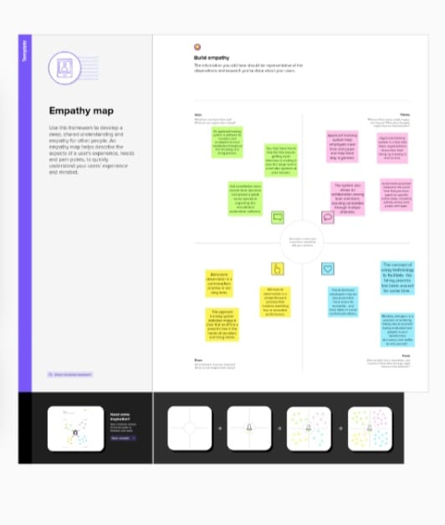

2.2 Ideation & Brainstorming map:

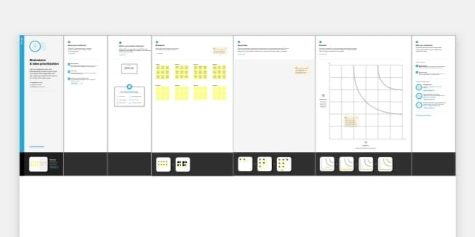

3 RESULT:

3.1.Data model:

|  |  |
| --- | --- |
| **Object name** | **Fields in the objects** |
| **School** | |  |  | | --- | --- | | **FIELD LABEl** | **DATA TYPE** | | **Address** | **Text area** | | **District** | **Text area** | | **State** | **Text area** | | **School website** | **Text area** | | **Phone number** | **Phone** | | **Number of Students** | **Roll-up summary** | | **Highest mark** | **Roll up summary** | |
| **Student** | |  |  | | --- | --- | | **Phone number** | **Phone** | | **Results** | **Picklist** | | **school** | **Master Detail relationship** | | **Class** | **Number** | | **Marks** | **Number** | |
| **Parent** | |  |  | | --- | --- | | **Parent number** | **Phone** | | **Parent address** | **Text area** | |

**3.2.Activity & screenshot:**

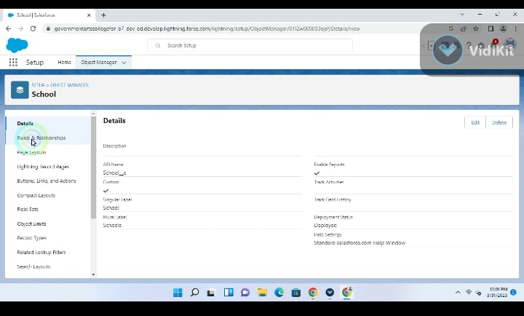

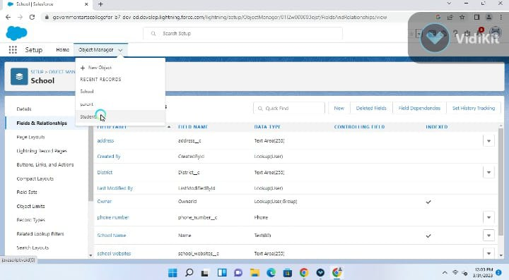

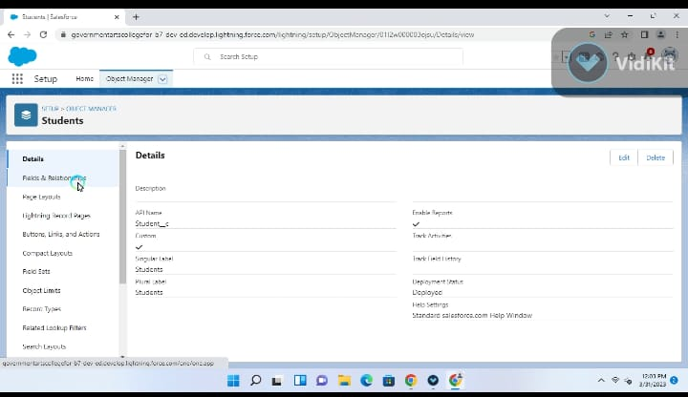

**4.Trailhead profile public URL:**

**Team lead-https://trailblazer.me/id/pdharshini96**

**Team member 1-https://trailblazer.me/id/nnithiya1**

**Team member 2-https://trailblazer.me/id/ppandiyarajeswari**

**Team member 3-https://trailblazer.me/id/niraj257**

**5.ADVANDTAGES:**

**\*Reduction in the cost of expenses**

**\*Improving the quality of service/product**

**\*Improving the organisation management process**

**\*History of work with each student**

**\*Easy implementation**

**DISADVANTAGES:**

* **Loss of collected information or records**
* **Not suitable for every business**
* **It eliminates the human element**
* **Having lots of security concerns**

**6.APPLICATIONS:**

**\*Lead centralization**

**\*Lead management**

**\*Sales management &automation**

**\*Field force automation**

**\*User management**

**\*Marketing communications and automation**

**7.CONCLUSIONS:**

**Customer relationship management enables a company to align it’s strategy with the needs of the customer in order to best meet those needs and thus ensure long term customer loyalty.**

**8.FUTURE COALS:**

**A CRM let’s you track data and analytics from your recruitment and marketing efforts so that it strikes a chord with prospective students.**